**Razvoj SFPzilla vmesnika**

Projekt na mojem PC:

D:\PROJECTS\ARDUINO\SFPZILLA

**Hardware:**

1. Arduino UNO ploščica

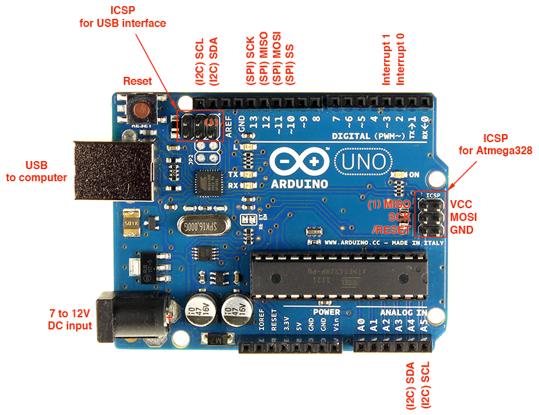

1. Kletka in konektor za 2 SFP modula + ohišje

Shema povezav na konektor – stran spajkanja!!! (**Zrcalna slika kot je v datasheet**):

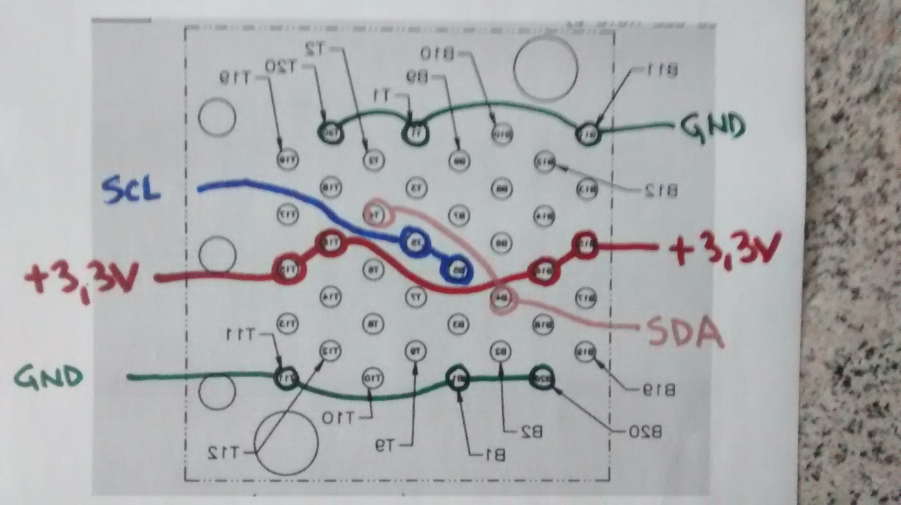

Sestavljen modul:

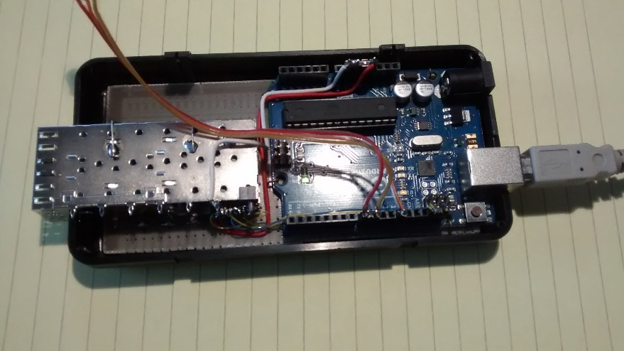

**Povezave:**

I2C – namenska pina na atmega823p + 2xpullup upor 10k

Dvobarvna led:

Pin 12 – Krmiljenje napajanja (0=ON)

PIN 9 – anoda 1 (katoda je vezana na maso) 1=ON

PIN 8 – anoda 2 (katoda je vezana na maso) 1=ON

Napajanje SFP: 3,3V iz konektorja preko tranzistorja 2N2907A:

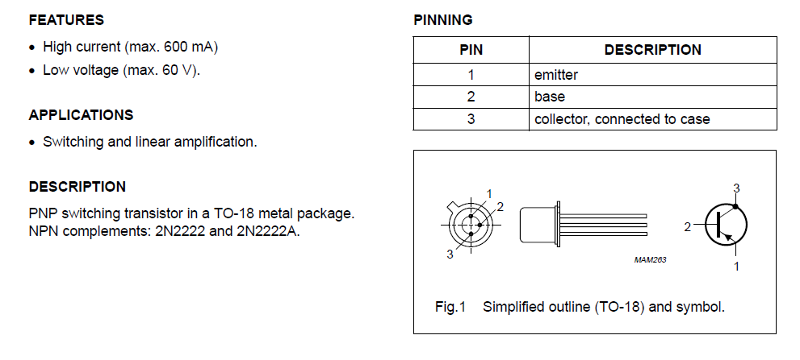

+ GND iz konektorja

Vklop napajanja: 1. verzija, ki ni delovala dobro:

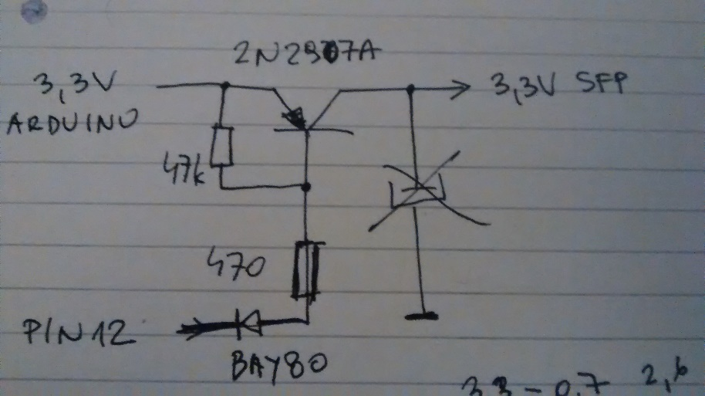

Vklop napajanja: 2. verzija z relejem:

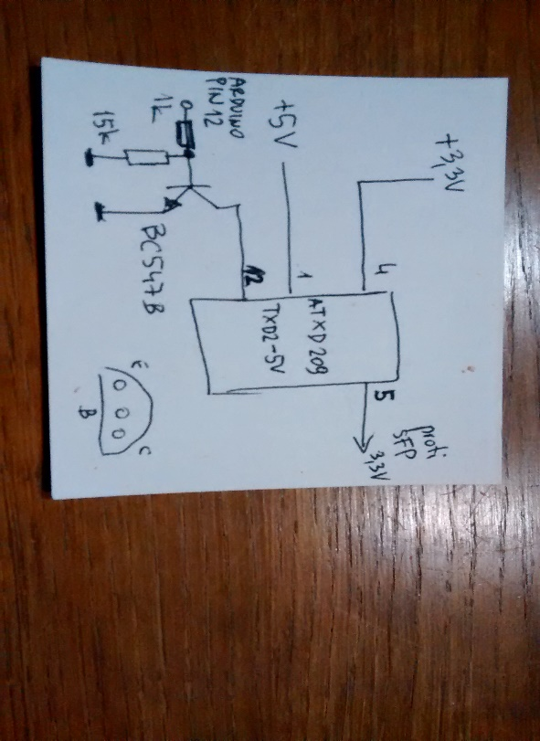

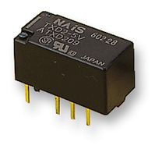

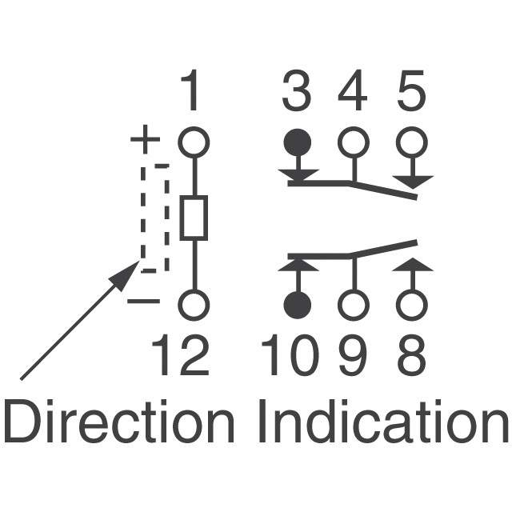

**SOFTWARE:**

* Arduino SW
* Program na PC: SFPzilla

**Arduino SW:**

**Projekt se nahaja tukaj:**

**D:\PROJECTS\ARDUINO\SFPZILLA\sketch_SFPzilla**

Izpis iz konzole (speed = 115200):

help

ping

device <DD> (set i2c device address to 0x<DD>)

offset <OO> (set i2c mem offset to 0x<OO>)

power on (set the SFP power ON)

power off (set the SFP power OFF)

read <NN> (read 0x<NN> bytes from SFP device 0x<DD> at offset 0x<OO>

write <dd> <dd> ... (write data <dd>.. to SFP device 0x<DD> at offset 0x<OO>

dump_bank_a0 (dump standard SFP bank A0)

dump_bank_a2 (dump standard SFP bank A2)

dump_bank_b0 (dump standard SFP bank B0)

dump_bank_b2 (dump standard SFP bank B2)

help

OK

**power off**

OK

**power on**

OK

**dump_bank_a0**

03 04 07 00 00 00 02 12 00 01 01 03 0c 00 0a 64 ...............d

00 00 00 00 4e 45 4f 50 48 4f 54 4f 4e 49 43 53 ....NEOPHOTONICS

20 20 20 20 00 00 00 00 50 54 37 33 32 30 2d 35 ....PT7320-5

32 2d 31 57 2b 20 20 20 31 2e 30 20 05 1e 00 d0 2-1W+ 1.0 ....

00 1a 00 00 41 30 35 31 31 37 36 32 31 31 39 20 ....A0511762119

20 20 20 20 31 31 30 35 32 31 20 20 58 b0 01 6f 110521 X..o

00 00 00 00 00 00 00 00 00 00 00 00 00 00 00 00 ................

00 00 00 00 00 00 00 00 00 00 00 00 00 00 00 00 ................

00 00 00 00 00 00 00 00 00 00 00 00 00 00 00 00 ................

00 00 00 00 00 00 00 00 00 00 00 00 00 00 00 00 ................

00 00 00 00 00 00 00 00 00 00 00 00 00 00 00 00 ................

00 00 00 00 00 00 00 00 00 00 00 00 00 00 00 00 ................

00 00 00 00 00 00 00 00 00 00 00 00 00 00 00 00 ................

00 00 00 00 00 00 00 00 00 00 00 00 00 00 00 00 ................

00 50 54 5f 30 33 31 2d 37 33 32 30 2d 31 31 39 .PT_031-7320-119

5f 56 33 2e 30 20 20 20 20 20 20 20 20 20 20 20 _V3.0

DONE

**dump_bank_a2**

64 00 d8 00 5f 00 e2 00 86 b8 77 18 84 c4 79 0c d..._.....w...y.

2f 7d 00 00 2c 19 00 00 11 58 03 76 0d c6 04 5b /}..,....X.v...[

35 7f 00 ac 1a d0 01 58 00 00 00 00 00 00 00 00 5......X........

00 00 00 00 00 00 00 00 00 00 00 00 00 00 00 00 ................

00 00 00 00 3e bb 5f fc 00 00 00 00 02 e1 00 00 ....>._.........

01 21 00 00 01 00 00 00 01 00 02 00 00 00 00 1c .!..............

22 30 78 80 00 00 00 08 00 00 00 00 00 00 00 f8 "0x.............

01 40 00 00 11 40 00 00 00 00 00 00 00 00 00 00 .@...@..........

00 00 00 00 00 00 00 00 00 00 00 00 00 00 00 00 ................

00 00 00 00 00 00 00 00 00 00 00 00 00 00 00 00 ................

00 00 00 00 00 00 00 00 00 00 00 00 00 00 00 00 ................

00 00 00 00 00 00 00 00 00 00 00 00 00 00 00 00 ................

00 00 00 00 00 00 00 00 00 00 00 00 00 00 00 00 ................

00 00 00 00 00 00 00 00 00 00 00 00 00 00 00 00 ................

00 00 00 00 00 00 00 00 00 00 00 00 00 00 00 00 ................

00 00 00 00 00 00 00 00 00 00 00 00 00 00 00 00 ................

DONE

**dump_bank_b0**

ff ff ff ff ff ff ff ff ff ff ff ff ff ff ff ff ................

ff ff ff ff ff ff ff ff ff ff ff ff ff ff ff ff ................

ff ff ff ff ff ff ff ff ff ff ff ff ff ff ff ff ................

ff ff ff ff ff ff ff ff ff ff ff ff ff ff ff ff ................

ff ff ff ff ff ff ff ff ff ff ff ff ff ff ff ff ................

ff ff ff ff ff ff ff ff ff ff ff ff ff ff ff ff ................

ff ff ff ff ff ff ff ff ff ff ff ff ff ff ff ff ................

ff ff ff ff ff ff ff ff ff ff ff ff ff ff ff ff ................

ff ff ff ff ff ff ff ff ff ff ff ff ff ff ff ff ................

ff ff ff ff ff ff ff ff ff ff ff ff ff ff ff ff ................

ff ff ff ff ff ff ff ff ff ff ff ff ff ff ff ff ................

ff ff ff ff ff ff ff ff ff ff ff ff ff ff ff ff ................

ff ff ff ff ff ff ff ff ff ff ff ff ff ff ff ff ................

ff ff ff ff ff ff ff ff ff ff ff ff ff ff ff ff ................

ff ff ff ff ff ff ff ff ff ff ff ff ff ff ff ff ................

ff ff ff ff ff ff ff ff ff ff ff ff ff ff ff ff ................

DONE

**dump_bank_b2**

ff ff ff ff ff ff ff ff ff ff ff ff ff ff ff ff ................

ff ff ff ff ff ff ff ff ff ff ff ff ff ff ff ff ................

ff ff ff ff ff ff ff ff ff ff ff ff ff ff ff ff ................

ff ff ff ff ff ff ff ff ff ff ff ff ff ff ff ff ................

ff ff ff ff ff ff ff ff ff ff ff ff ff ff ff ff ................

ff ff ff ff ff ff ff ff ff ff ff ff ff ff ff ff ................

ff ff ff ff ff ff ff ff ff ff ff ff ff ff ff ff ................

ff ff ff ff ff ff ff ff ff ff ff ff ff ff ff ff ................

ff ff ff ff ff ff ff ff ff ff ff ff ff ff ff ff ................

ff ff ff ff ff ff ff ff ff ff ff ff ff ff ff ff ................

ff ff ff ff ff ff ff ff ff ff ff ff ff ff ff ff ................

ff ff ff ff ff ff ff ff ff ff ff ff ff ff ff ff ................

ff ff ff ff ff ff ff ff ff ff ff ff ff ff ff ff ................

ff ff ff ff ff ff ff ff ff ff ff ff ff ff ff ff ................

ff ff ff ff ff ff ff ff ff ff ff ff ff ff ff ff ................

ff ff ff ff ff ff ff ff ff ff ff ff ff ff ff ff ................

DONE

**offset 10**

OK

**device 50**

OK

**read 20**

00 00 00 00 4e 45 4f 50 48 4f 54 4f 4e 49 43 53 20 20 20 20 00 00 00 00 50 54 37 33 32 30 2d 35

OK